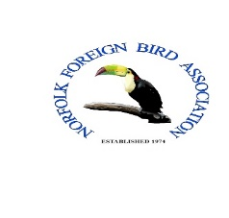Membership form for the
NORFOLK FOREIGN BIRD ASSOCIATION.

FIRST NAME

SURNAME

ADDRESS

POST CODE

FULL TELEPHONE NUMBERS

E-MAIL ADDRESS

Subscription fee:

Member: £6.00 per year.

Partnership Membership: £12 per year.

Juniors under 16: £1 per year.
Cheques & Postal Orders should be payable to the “Norfolk Foreign Bird Association”.
Membership runs from 1st January to 31st December each year.
Please return subscription form to the Membership Secretary:
Mr LES TOOLEY, C/O Norfolk FBA. “Fiveways” Richmond Rise, Reepham.
Norfolk. NR10 4LS.
Please include a stamped addressed envelope.

