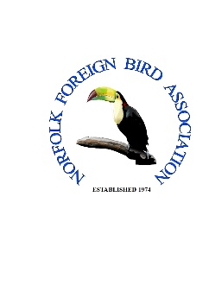
Name of Society Judge

Show Secretary’s Details
Name
Telephone Number
Email Address
Postal Address

Post Code

Level of Patronage applying for, please tick appropriate box
SUPPORT PATRONAGE: £3.00 plus large stamped addressed envelope.
Includes 3 Rosettes.

FULL PATRONAGE: £5.00 plus large stamped addressed envelope.
Includes 5 Rosettes.

Please note: Rosettes to be awarded at Foreign Judge discretion
All Applications to include a 11' x 8' (A4 type) Stamped Addressed Envelope (Large Letter Stamp Required)
Norfolk FBA Patronage Secretary NFBA c/o Mr Brian Rudling
30 Beecheno Road
Norwich NR5 8TH

Date Application Submitted

Submitted by

For further information call Patronage Secretary on: 01603 507064

